

Sir Syed University of Engineering & Technology Department of Software Engineering

**Project Report of Programming Fundamentals**

**Project Title: English to Urdu Translater**

|  |  |
| --- | --- |
| **Group Members:** | **Hasan Raza** |
| **Roll numbers:** | **129** |
| **Section:** | **C** |

**Purpose of Project:**

**English To Urdu Translater :**

The mean of making this English to Urdu Translater is to get more familiar withpython**.**Through this Project you can find out the meaning of every word.

**Reference Code:**

There is no reference code for this. For this project I have visited the google and w3school for the built libraries and modules and I have watch some video related to that Libraries

**Modified Code:**

import tkinter as tk

from googletrans import Translator

window=tk.Tk()

window.title('Translator')

window.geometry('200x70')

def translation():

word=root.get()

translator=Translator(service_urls=['translate.google.com'])

translations=translator.translate(word,dest='ur')

l1=tk.Label(window,text=f'Translated in Urdu:{translations.text}',bg='yellow')

l1.grid(row=2,column=0)

l=tk.Label(window,text='Enter Word : ')

l.grid(row=0 ,column=0,sticky='W')

root=tk.Entry(window)

root.grid(row=1,column=0)

window.geometry('300x300')

button=tk.Button(window,text='Translate',command=translation)

button.grid(row=1,column=2)

window.mainloop()

**Project Output: (**contain screenshots of your modified code**)**

**Code Output**

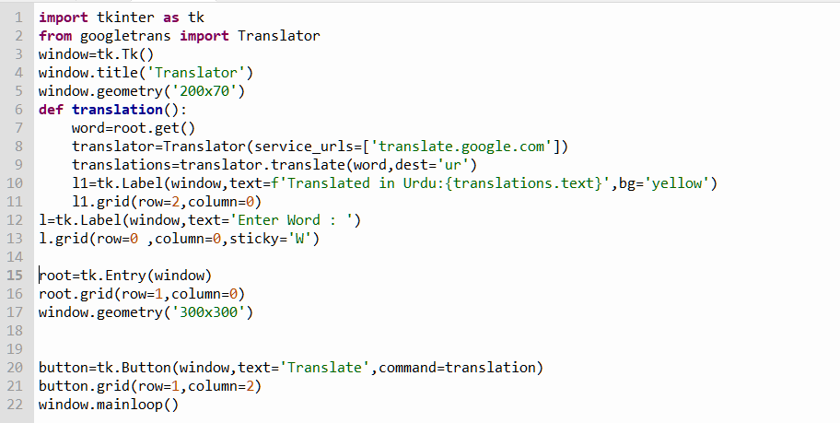

**Program Output**

